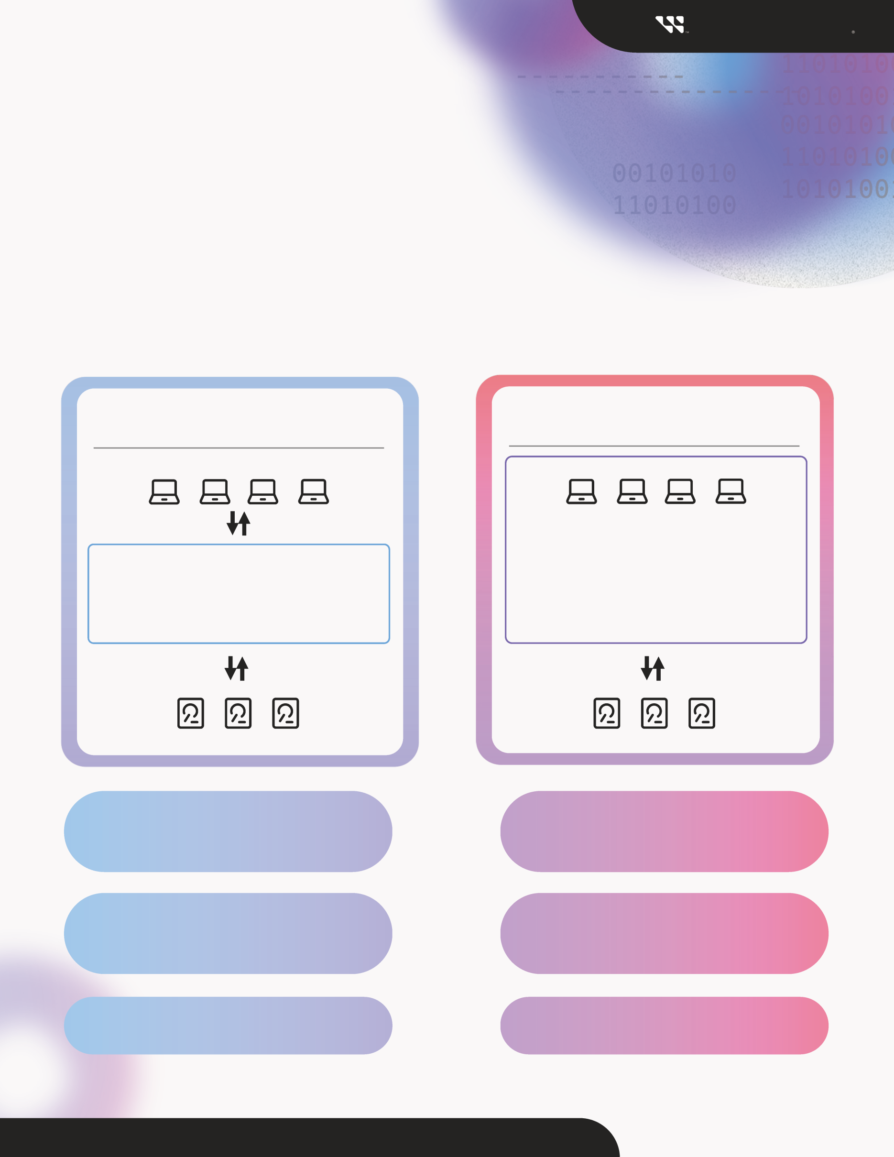

© 2023 WESTERN DIGITAL CORPORATION OR ITS AFFILIATES ALL RIGHTS RESERVED

*Speak to your Western Digital sales representative to learn more about requirements for SMR adoption.*

**SET UP EFFORT**

**Low**

*(Drop-in for some applications)*

**High**

*(Requires custom software)*

**SMR HDDs perform like CMR HDDs**

across a broader set of applications.

**BENEFIT**

**Enables “drop-in” adoption of SMR HDDs** with faster, low-cost path for some applications.

A **custom-designed software stack** that is optimized to follow SMR write rules.

**BEST FOR**

Existing applications where **writes are heavily sequential** or **cold storage** or **smart video**.

Customer re-writes the entire software stack to use SMR HDDs

Using “btrfs” filesystem “hides” SMR complexity, allowing drop-in use of select legacy applications

SMR-Aware

# SMR-Friendly

**Host-managed Shingled magnetic recording** (**SMR**) hard drives deliver next-generation capacity levels, improved system density, and a more efficient footprint to your data center.

Before adopting this technology, determine whether an “**SMR-friendly**” or “**SMR-aware**” adoption strategy is the best fit for your Linux-based application.

**Western Digital**

**SMR-Friendly vs. SMR-Aware**

Two paths for SMR HDD adoption